William Faunce

Professor Roberts

COS 125

15 September 2017

A2WilliamFaunce

Part I

1. True
2. True
3. True
4. False
5. True
6. False
7. False
8. True
9. False
10. 5
11. 0
12. What is the output of the code?

d. Larry

Curly

1. What input values of x produce output: **Medium**?
   1. 2, 3
2. What is the output of the code?

b. BYE

Screenshots:

1. Invalid data tests

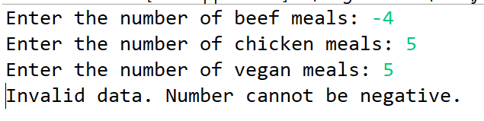

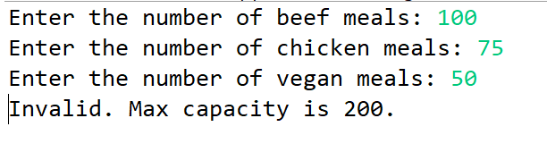

1. Sample run of party with 50 beef, 25 chicken, and 35 vegan meals.

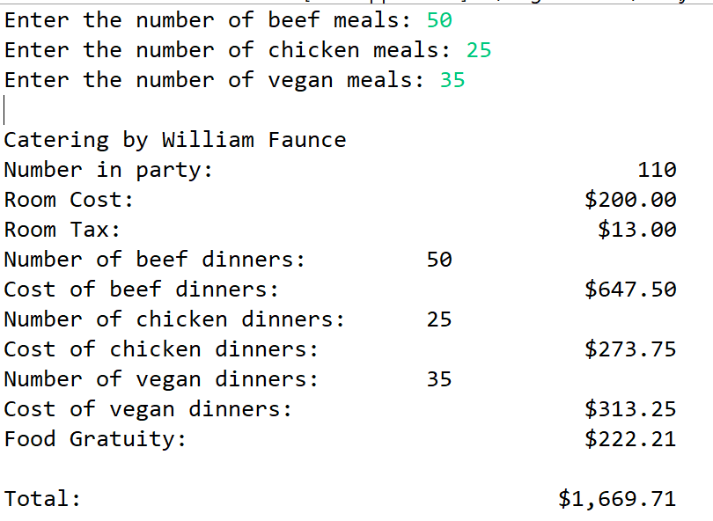

1. Sample run of party with only 25 vegan meals.